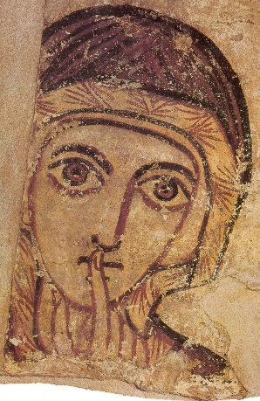
Orthodox Christian Parish of St Anne, Northampton
Study Weekend 2016
Eastern Christian prayer: an intensive introduction
20 May - 22 May 2016
Eastern Christianity is becoming more visible in the UK, especially through the popularity of icons. This study weekend is an intensive introduction to the spiritual life of Orthodox Christians. It will be a mixture of praying Orthodox services, some theological talks, an introduction to church singing, baking bread and icon painting. .
The weekend will take place in the context and experience of Orthodox Christian worship, of the Russian tradition but conducted entirely in English.
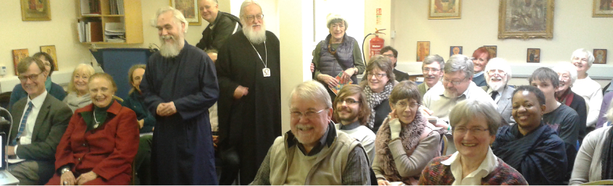

Arrangments
The weekend will start with Vespers on Friday evening at 7pm, and work through the prayers for the day, through to the Divine Liturgy on Sunday, and finish with Sunday Vespers at 6pm. At the end of each day we will return to our home. For those who do not wish to travel home, or live far away, accommodation can be arranged in the locality. We can recommend the Plough Hotel, a short walking distance from the church. http://www.the-plough-hotel.co.uk/
Everyone is welcome, regardless of church membership. Communion on Sunday will, however, be restricted to Orthodox Christians. You will understand why this is the case during the weekend
There is no parking at St Anne’s, so the nearby town centre is recommended, or residential streets in Far Cotton, within walking distance. The church is also ten minutes’ walk from the train station and the bus station in the town centre
The cost of the weekend is £20 to cover simple food and to make an advanced booking. If you would like to make a donation to support further study and retreat experiences, this will be gladly received on day.
Places are limited to 15 participants. The retreat will be led by Father Timothy Curtis, a priest of over 15 years, and an academic at the University of Northampton. He will be joined by specialists in church singing, theology and iconography but it will be a practical and prayerful weekend rather than a theological one.
Booking Form
I would like to book a place for the Study Weekend 2016 Eastern Christian prayer: an intensive introduction 20 May - 22 May 2016
Name:

Address:

Email:
Phone Number:

Parish to which you are attached:
Denomination:
If there are insufficient attendees, the weekend maybe cancelled or postponed. Donations will be returned
I enclose a booking fee of £20
Cheques to be made out to St Ragener of Northampton Trust or pay via paypal using this email trust@saintannesnorthampton.org.uk
All correspondence should be directed to

Fr Timothy Curtis
St Anne’s Orthodox Church,
7 Cattlemarket Rd,
Northampton NN1 1HL
frtimothy@googlemail.com
Tel: 07967 123471

